

**SCHOOL OF INFORMATICS & IT**

**Part 1: Project Proposal**

Student Name (Matric Number) :Geng Yue 2403880d

Tutorial Group : P02

Jenny LING (TP)

Tutor : Ms Hu Huimei

Submission Date : 10/5/225

**Declaration of Originality**

I am the originator of this work and I have appropriately acknowledged all other original sources used as my references for this work.

I understand that Plagiarism is the act of taking and using the whole or any part of another person’s work, including work generated by AI, and presenting it as my own.

I understand that Plagiarism is an academic offence

and if I am found to have committed or abetted the offence of plagiarism in relation to this submitted work, disciplinary action will be enforced.

**Declaration on the use of Generative AI tools for assignments**

|  |
| --- |
| Describe how you have used Generative AI tools such as ChatGPT or Dall.E-2 in your assignment.  Show snapshots of the conversations with the AI tool (i.e., the prompts you used and the response you get from the AI tool). |
| **<https://chatgpt.com/share/681f566d-b190-8001-8781-78ceafd89c2a>**  **1746884249425** |
| How do you indicate the reference?  The content generated by AI tools are not retrievable except by the user who generated them, so they are considered non-recoverable sources. Although non-recoverable data or quotations in APA Style papers are usually cited as personal communications, with ChatGPT-generated text there is no person communicating. Quoting text from ChatGPT chat is therefore more like sharing the output of an algorithm, with a reference list entry and the corresponding in-text citation.  According to the official APA Style site, ChatGPT references should be cited as:  E.g. OpenAI. (2023). *ChatGPT* (Sep 25 version) [Large language model].  <https://chat.openai.com/chat> |

**Important Note:**

* Do not copy answers produced by the AI tool in totality as it is considered as plagiarism.
* Do not rely on any information produced by the AI tool blindly. You should always verify the answer with other sources. Do not assume that these answers provided by the AI tool are correct.

To achieve quality outputs from the AI tool, you should provide good prompt that is clear and specific. Be precise and provide context. Avoid asking open-ended questions.



School of Informatics & IT

**Mobile App Development (CIT2C18)**

**AY 25/26 Apr Semester**

**Project Proposal**

**(Part 1)**

|  |  |
| --- | --- |
| Name: | Geng Yue |
| Admission Number: | 2403880d |
| Class: | P02 |

Table of Contents

Application 5

Project Scope 8

Database Design 16

Design Screenshots 20

Widget Tree 25

The yellow text in each section is provided as a guide. Please make sure to REMOVE them before submitting your work.

# Application Description

|  |  |
| --- | --- |
| **Problem Statement** | Singapore faces an urgent waste management challenge despite its high-tech infrastructure. In 2023, the nation generated about 6.86 million tonnes of solid waste, but only 52% was recycled. The domestic recycling rate remains especially low at just 12%, indicating that household waste largely goes unsalvaged. Each person in Singapore produced approximately 0.88 kg of waste per day in 2023. At this rate, the country's only landfill (Semakau) will be exhausted by 2035. A major contributor to this problem is the disposal of still functional consumer goods— ranging from clothing to electronics— into landfill load and squandering resources. While recycling programs exist, recycling alone is not keeping up; for example, plastic recycling in Singapore was only 5% in 2023, and paper recycling has declined to 31%. This indicates a need for solutions higher up the waste hierarchy (reuse and reduce, rather than just recycle).  By extending product lifecycles by reuse and exchange rather than disposal, we can avoid heaps of waste piling up in landfills and conserve resources. However, there is no convenient, cool outlet for Singaporeans. Without such an outlet, most things that might be repurposed or rehomed end up in the trash, exacerbating the city-state's sustainability issues. |
| **Application Name** | GreenSwap |
| **Target Audience** | GreenSwap's primary target market is young, eco-conscious urban residents in Singapore, aged around 18 to 35. They are tertiary students, young professionals, and young couples who are digitally literate and receptive to green living ideas. Surprisingly, young people in Singapore have increasingly demonstrated eco-awareness: one in two young people have made lifestyle changes to reduce climate change, for example, recycling more and utilizing reusable products. They are choosing not-wasteful consumption, like the way the youth are avoiding fast fashion and opting to reuse or buy second-hand clothes to reduce wastage. They are a well-connected generation via smart phones and social media, so a mobile application is the ideal platform to communicate with them. They value convenience, as well as congregating in groups – something shared with existing platforms like Facebook Marketplace or Carousell which they use for second-hand goods. But unlike in traditional marketplaces, GreenSwap is aimed at individuals who are sustainability-motivated, rather than profit-motivated. Our intended users prefer to live in space-constrained urban areas and are thus keen to declutter by donating items they no longer need, and equally keen to buy second-hand products as a way of saving themselves and the planet. Targeting young adults within the urban environment of Singapore, the app will be able to leverage their enthusiasm, peer network, and higher interest in greening. The users are likely to be enthusiastic advocates of a platform that aligns with their values and promote GreenSwap in order to foster a lively community involved in waste reduction through joint efforts. |
| **Solution Justification** | Environmental & Circular‑Economy Impact  GreenSwap operates at the top of the waste‑management hierarchy—reuse—by enabling peer‑to‑peer exchanges that keep still‑functional items in circulation. Each successful swap displaces the production of a brand‑new good and therefore avoids the extraction of virgin raw materials, the energy consumed in manufacturing, and the emissions generated in long‑haul logistics. Life‑cycle assessment models show that reusing a medium‑sized household appliance can save up to 80 % of its cradle‑to‑grave carbon footprint and cut water consumption by 70 % compared with buying new. In aggregate, a community of 10,000 active users exchanging just one item per month would eliminate ≈ 1,200 t CO₂e annually—equivalent to taking 260 passenger cars off Singapore’s roads.  Beyond carbon, the platform supports a regenerative circular economy: items handed off to new owners circulate through multiple life cycles instead of becoming single‑use purchases. This postpones their end‑of‑life entry into incinerators or landfills and minimizes the creation of toxic ash that must be land‑filled offshore—currently a critical constraint for land‑scarce Singapore.  Alignment with National & Global Initiatives  GreenSwap is aligned with Singapore's Zero Waste Masterplan, which aims for a 70 % national recycling rate in 2030 and focuses on upstream waste reduction over downstream treatment. Its reuse-first approach also supports the Extended Producer Responsibility (EPR) system coming onstream in 2025 for electronic waste, providing consumers with a prompt outlet to transfer functioning devices to second users before being sent for recycling.  Across the world, GreenSwap is complementary to the UN Sustainable Development Goals 11 & 12 (sustainable cities and responsible consumption & production) and the ASEAN Circular Economy Framework 2025. With avoided emissions and material savings calculated in the app, GreenSwap provides data which can feed straight into corporate ESG reporting and national circular-economy dashboards.  User & Market Benefits  GreenSwap delivers real advantages on a number of fronts: users get what they need at little or no cost—a very attractive proposition within a environment of rising living expenses—while local exchanges foster social cohesion and community spirit. The application's gamified elements (swap points, tiered badges, carbon‑savings counters and leaderboards) translate intangible sustainability goals into fun, measurable micro‑behaviours. Market signals validate feasibility: the global second‑hand goods market surpassed USD 150 billion in 2023 and is expanding at around 15 % CAGR, and regional platforms such as Carousell registered a 40 % year‑on‑year growth in recommerce listings, indicating robust demand for reuse alternatives. Behavioural‑science research underscores that convenience, social proof and timely feedback are key drivers of sustainable habits—precisely the levers GreenSwap integrates to maximise repeated eco‑actions.  Why a Mobile App?  A mobile‑first approach is essential for scale and convenience. With smartphone penetration in Singapore at ≈ 88 %, a dedicated app reaches users wherever they are; built‑in cameras enable one‑minute listings via instant photos and auto‑cropping; GPS powers hyper‑local matching that slashes transport emissions; and push notifications keep engagement high the moment an item is claimed or a sought‑after listing appears. Integration of NFC or QR scanning verifies hand‑overs, while progressive‑web‑app caching keeps browsing and posting functional even in low‑signal environments. Web portals, social‑media groups and episodic swap meets cannot match this blend of real‑time discovery, structured data capture, location intelligence, gamified feedback and automated carbon‑ledger tracking. In short, only a mobile platform can weave hyperlocal logistics and rewarding feedback into a single pocket‑sized tool, transforming ad‑hoc swapping into a scalable, data‑driven pillar of Singapore’s circular economy. |

Reference:

**CNA News** – Ganesan, N. (2024, June 19). Singapore’s recycling rate falls to 52% in 2023, decline from 10 years ago. Channel NewsAsia. Retrieved from https://www.channelnewsasia.com [channelnewsasia.com](https://www.channelnewsasia.com/singapore/recycling-rate-domestic-waste-statistics-2023-nea-4418776" \l ":~:text=In 2023, about 6,57 per cent in 2022" \t "_blank)​[channelnewsasia.com](https://www.channelnewsasia.com/singapore/recycling-rate-domestic-waste-statistics-2023-nea-4418776" \l ":~:text=fluctuations,rates, NEA added" \t "_blank).

**The Straits Times** – Singapore’s domestic recycling rate stalls at 12%, the lowest in over a decade. (2024, June). The Straits Times. (Referenced via Ground News summary) [ground.news](https://ground.news/article/singapores-recycling-rate-falls-to-52-in-2023-decline-from-10-years-ago_9c4d80" \l ":~:text=Singapore%E2%80%99s domestic recycling rate stalls,com" \t "_blank).

**TODAY Online** – Goh, C., & Lou, S. Y. (2022, November 4). TODAY Youth Survey: Climate crisis strikes fear, pessimism but youths believe Govt policies can make the most impact. TODAY. Available at https://www.todayonline.com [todayonline.com](https://www.todayonline.com/singapore/today-youth-survey-climate-crisis-fear-pessemism-government-policies-2034066" \l ":~:text=The TODAY Youth Survey showed,measures to combat climate change" \t "_blank)​[todayonline.com](https://www.todayonline.com/singapore/today-youth-survey-climate-crisis-fear-pessemism-government-policies-2034066" \l ":~:text=Ms Aishwarya is another youth,amount of waste it produces" \t "_blank).

**Cognitive Market Research** – Dharmadhikari, S. (2025, March). Second Hand Apparel Market Report 2025 (Global Edition). Cognitive Market Research. (Excerpt on global second-hand market size) [cognitivemarketresearch.com](https://www.cognitivemarketresearch.com/second-hand-apparel-market-report" \l ":~:text=Second Hand Apparel Market Report,Global Edition" \t "_blank).

# Project Scope

**Authentication-related:**

GreenSwap will implement secure authentication to protect user data and tailor content to each user. At least three authentication-related functions are included:

|  |  |  |
| --- | --- | --- |
| **No.** | **Function Name** | **Description** |
| 1. | User Registration | The registration features an authentication system with sign-up through email or username and password. It utilizes strong passwords with more than 8 characters in a mix of uppercase and lowercase letters, along with at least one number and one special character. All usernames are unique and include email verification. Activation of the account is accomplished by sending the activation link via email, and upon verification, the system automatically logs the user in for immediate access. |
| 2. | Login | The Login process employs a number of security controls to protect user accounts. Passwords are stored securely through bcrypt hashing so that they cannot be easily compromised even during data breach. As an additional measure against brute force attacks, automatic lockout for 15 minutes is imposed after five consecutive unsuccessful login attempts. For increasing user convenience while ensuring security, a "Remember Me" feature employs JWT refresh tokens so that users can keep authenticated sessions up to seven days without needing repeated re-authentication. |
| 3. | Password Recovery | The authentication system has a secure "Forgot Password" recovery process. When activated, the system generates a time-based one-time password (OTP) or reset link via email or SMS, according to the user's preference. After filling out the reset form, the same strength checks are triggered to ensure that the new password meets all security requirements, maintaining the integrity of the users' accounts in password recovery. |
| 4. | Logout | The Logout system has complete session management capabilities. JWT revocation is server-side to immediately terminate sessions when necessary for security purposes. There's also a session management interface that users can use to view all current sessions from any device and revoke any suspicious-looking or no longer needed session, with complete control over their access points on their account. |
| 5. | Google Sign-In | Google Sign-In supports OAuth 2.0 integration to minimize the login experience. When users authenticate with an OAuth provider for an existing e-mail address, the system connects this authentication means with their subsequent logins for the same e-mail address by default. On first-time client use, a profile is auto-created based on accessible OAuth data. In keeping with its commitment to privacy, the integration only requests minimal scopes, i.e., restricted to email and fundamental profile information, to enable users to remain in command of their own personal information without loss of single sign-on authentication convenience. |
| 6. | Guest Sign-In | The system provides limited functions that can be used for temporary visitor accounts with read permissions. When users attempt to begin operations requiring strict rights such as swaps or obtaining points, a smart upgrade alert receives displayed, encouraging signing up for full capability. All data gained on the guest session receives moved immediately to the newly formed permanent one during signup, providing an impeccable handover experience without forfeiting the users' actions and settings. |

**Authentication Flow：**

**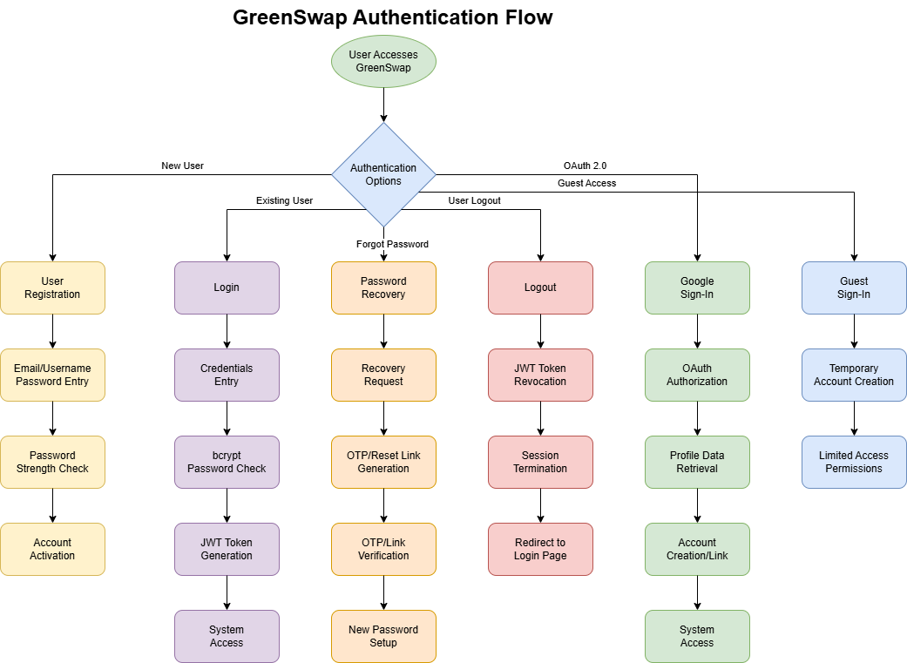**

**CRUD related (ONE set ONLY):**

The core of GreenSwap is managing the item listings that users want to swap, sell or buy. We identify a primary entity “Item” and implement full Create, Read, Update, Delete (CRUD) functionality for this entity:

|  |  |  |  |
| --- | --- | --- | --- |
| **No.** | **Function Name** | **Description** | **Technical Approach** |
| 1. | C: Create Items | Users begin by selecting Swap or Sell. The form then adapts: swap listings feature a "Desired item/category" field, and sale listings feature price and shipping fields. All listings require a descriptive title, a short but descriptive text, a category tag, a condition rating, and at least one photo. A live thumbnail preview shows what the card will appear like in the feed, and inline validation (duplicate‑image check, price format, required fields) prevents incomplete submissions. On save, a confirmation toast appears and the new card is instantly visible beneath the Swap or Buy tab, giving owners instant feedback and other users real‑time access to new listings. | When a listing is submitted, the client sends a single POST request that includes the chosen purpose (Swap or Sell) plus the relevant fields (desired-item or price and delivery, never both). The server validates that mandatory fields match the selected purpose, blocks duplicate images by hashing, and enforces price format and size limits. A new record is saved with status = Active, along with timestamps; image files are uploaded to object storage and their URLs stored in the record. The response returns the new item’s ID and purpose so the UI can immediately display the card in the correct tab and show a brief “Listing created” toast. Edge-case checks ensure that mixed purposes, missing key fields, or oversize images trigger clear error messages before anything is committed to the database. |
| 2. | R: Read Items | The marketplace is split into Swap and Buy tabs, each loading items whose listingPurpose matches and whose status is Active. Cards show a thumbnail, title, category chip. Depend on purpose, there is either a price ribbon or a “Looking for…” badge. A sticky filter bar offers immediate chips for category, condition, and an auto‑suggesting search box that updates results as the user types. Pull‑to‑refresh loads fresh listings and scroll position is preserved between tabs so browsing is smooth even on low‑memory devices. | The client requests two filtered feeds—one for Swap listings, one for Sell—by passing the chosen tab and optional query parameters (keyword, category, distance, condition) in a GET call. The server builds an index-friendly query that returns only status = Active items matching those filters and paginates the results to keep each payload small. Returned data include a thumbnail URL, title, purpose flag, and key meta (price or desired item). Infinite scroll or "Load more" retrieves the next page using a cursor token, not repeatedly scanning the same database. When a user toggles from Swap to Sell, the client aborts any outstanding request and re-queries with the new purpose flag so that the two feeds never become confused. Edge cases consist of empty states ("No items match your search") and offline caching: the last successful page is cached locally so users see something even with a slow connection. |
| 3. | U: Update Items | Owners tap the three‑dot menu on their listing to open an edit screen pre‑filled with existing data. They can refine wording, adjust the desired swap item, change price, add or remove photos, and toggle availability, but the original purpose (Swap or Sell) remains locked, with a note explaining that purpose changes require re‑listing to protect buyer confidence. A live preview updates as fields change, and saving triggers a brief spinner followed by a success snackbar. Updates appear instantly in the owner’s feed and detail view, keeping information fresh and reliable for potential traders. | When the owner taps “Edit,” the app loads the current listing into a pre-filled form. Upon save, the client sends only changed fields plus the item ID and purpose flag in a PATCH request. The server first confirms ownership, then validates that edits respect the listing’s original purpose (e.g., a Swap item cannot suddenly gain a price) and that any new images meet size constraints. An optimistic update instantly refreshes the local card so the user sees the change without waiting; if the server later rejects the edit because of duplicate title, invalid price, or status already “Completed”, the app rolls back and shows a clear error toast. Status changes (Active → Archived or Active → Completed) are protected by business rules: an item marked Completed can no longer be edited except to update its photo for history. Successful updates bump the `updatedAt` timestamp, trigger a lightweight push to watchers’ feeds, and invalidate cached pages so other users see the latest details on next scroll. |
| 4. | D: Delete Items | When a swap or sale is completed, the owner taps “Remove Listing.” A brief notice makes clear that the card, photos, and chat thread will vanish from the public feed and from “My Listings,” leaving behind only a lightweight transaction record which includes item title, agreed price or desired item, parties involved, date, and rating—for history and dispute reference. Once confirmed, the listing slides out of view, a toast says “Listing removed,” and cached feeds refresh so no one sees outdated offers. If a draft listing is withdrawn before any deal is struck, it is deleted outright with no record saved, keeping the marketplace lean and clutter-free. | When a swap or sale is completed (or an active listing is withdrawn), the client issues a DELETE request to /api/items/{itemId}, and the server first verifies that the caller is the listing owner and that the item remains active. It then writes a concise transaction record—containing the item ID, the counterparty’s user ID, the agreed price or desired item, timestamp, and a placeholder for rating—into the Transactions table before permanently removing the item’s database row, its associated images from storage, and any chat history. A real-time remove (via WebSocket or equivalent) is dispatched to ensure that every online client instantly delete the removed card from streams and close out any active conversational streams. If the item does not exist or the current user lacks the necessary permissions, the API responds with a 404 or 403 error and the UI reinstate the card with an "Unable to remove listing" tooltip. By retaining only the light transaction record and removing cumbersome media and listing information, the system maintains an auditable history of swaps without cluttering storage or inundating the public marketplace. |

CRUD Flowchart：

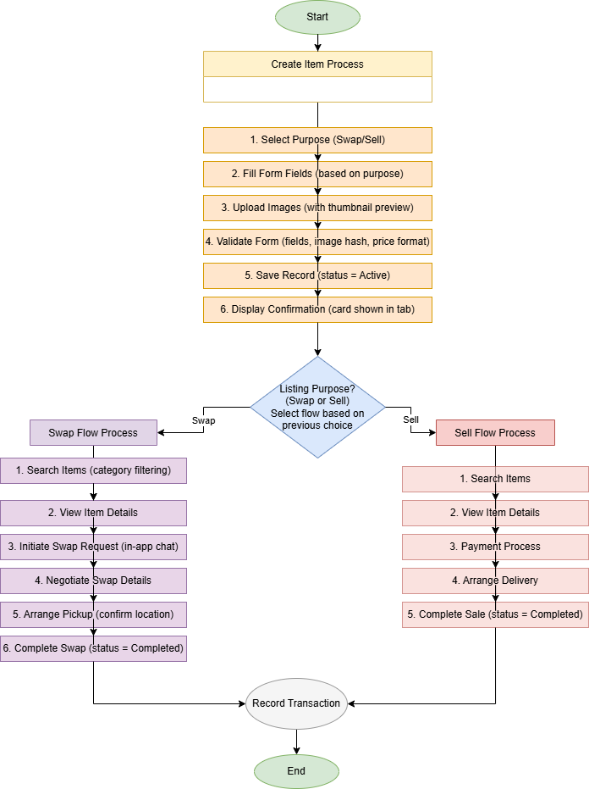

**Others, if any:**

In addition to authentication and basic item management, GreenSwap includes several **features to promote sustainability and user engagement**. These features differentiate GreenSwap from generic buy/sell platforms and encourage users to participate more in eco-friendly swapping. At least five major features are planned:

| **No.** | **Feature Name** | **Description** |
| --- | --- | --- |
| 1. | **Advanced Search & Filter** | An intensive search facility allows users to search for individual items easily. Users can type key wordsto search and filter using options such as category , condition , or location (. It makes it more user-friendly to allow users to find desired items in the expanding list of exchanges. With the ease of item finding, it increases the rate of satisfaction among users as well as swap success. |
| 2. | **In-App Chat & Requests** | Integrated messaging enables users to communicate within the app to arrange swaps. When a user is interested in an item, they can tap a chat button, opening a chat interface where they can discuss item details and propose an exchange or pickup arrangement. All messages are stored securely on the server, giving moderators a verifiable trail if disputes or safety concerns arise. A short banner inside every new chat reminds both parties to meet in well-lit public locations and verify the item before handing it over. Keeping conversations in-app therefore delivers convenience, preserves a safety audit log, and reduces the need to share personal contact details. |
| 3. | **Gamified Rewards (Points & Badges)** | To drive engagement, GreenSwap employs layered gamification. Users still collect points for positive actions—completing a swap, gifting an item, or closing a problem-free transaction—but each action also generates an impact score that converts real-world savings into easy-to-grasp metrics. For example, giving away a gently used blender might register 2 kg of CO₂ avoided, 0.8 kWh of energy saved, and the platform translates those numbers into a friendlier badge: “Equal to planting 0.1 trees.” These cumulative impact totals sit beside a user’s level and badge collection on their profile, offering both competitive bragging rights and a tangible sense of environmental contribution. By rewarding swaps with points and visualising carbon, energy, and “trees-planted” equivalents, the system taps into young users’ playful, data-driven mindset—making sustainable behaviour fun, measurable, and socially shareable. |
| 4. | **Sustainability Tips & Tutorials** | GreenSwap will have a section with learning content. For example, "DIY Repair Tutorials" and sustainable living tips. Short articles or videos which possibly from collaborators or users teach users how to fix common things or repurpose things in creative ways. By integrating this content, the app not only facilitates swapping but also equips users with knowledge on how to make their belongings last longer. This aspect serves the larger purpose of the app as sustainability learning and engages people even when they are not actively exchanging. |

Other notable features include **user profiles** (where one can see their own items, points, badges, and impact stats), **notifications** (alerts when a message is received or when new items matching one’s interests are listed), and **moderation/reporting tools** (to ensure the platform stays safe and items exchanged adhere to guidelines). These, combined with the features above, create a holistic platform that not only enables item exchange but actively encourages a sustainable lifestyle and community engagement.

# Database Design

The GreenSwap schema is implemented in MySQL 8.0 and consists of three core tables—Users, Items, and Transactions which together support all app functions while enforcing data integrity via primary/foreign keys, UNIQUE and CHECK constraints, and auditing fields (created\_at, updated\_at). The ER diagram below uses crow-foot notation to show cardinalities, and is followed by a detailed data dictionary for each table.

### ER Diagram

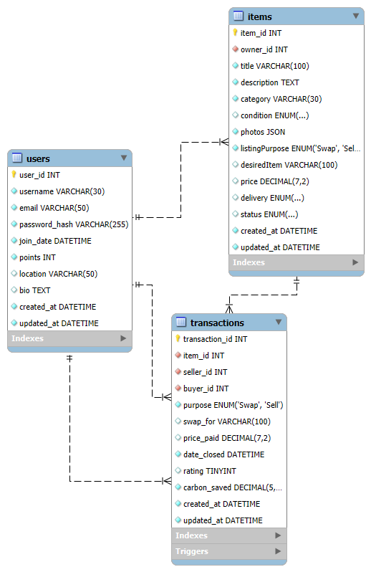

# Data Dictionary

**Relationship summary**

| Relationship | Cardinality | Business rule |
| --- | --- | --- |
| Users → Items | 1 : More | A user can list multiple items; an item has one owner. |
| Users → Transactions | 1:More (per role) | A user can appear in many transactions as seller / giver or buyer / receiver. |
| Items → Transactions | 1:1 (optional) | An item may be involved in zero or one transaction. |

(Auxiliary tables—e.g., Messages for chat or Categories for taxonomy—are intentionally excluded to keep the Part 1 proposal focused on the **minimum viable schema**. The design remains extensible for future iterations.)

This refined description, together with the ER diagram and data dictionary, clearly documents how data entities interact and supports all required app features: listing management, secure ownership validation, swap history, and sustainability metrics.

**Table: Users** – stores registered user accounts.

| Field | Type | Key / Constraint | Description | Default |
| --- | --- | --- | --- | --- |
| user\_id | INT(8) | PK, AUTO\_INCREMENT | Unique user ID | – |
| username | VARCHAR(30) | UNIQUE | Display name | – |
| email | VARCHAR(50) | UNIQUE | Login & recovery | – |
| password\_hash | VARCHAR(255) | – | Bcrypt hash | – |
| join\_date | DATETIME | – | Registration timestamp | CURRENT\_TIMESTAMP |
| points | INT(6) | – | Reward points | 0 |
| location | VARCHAR(50) | – | User neighbourhood | NULL |
| bio | TEXT | – | Profile text | NULL |
| created\_at | DATETIME | – | Row creation time | CURRENT\_TIMESTAMP |
| updated\_at | DATETIME | – | Row last-update time | CURRENT\_TIMESTAMP ON UPDATE CURRENT\_TIMESTAMP |

Users  
Stores authentication and profile data. user\_id is the primary key, while email and username are marked UNIQUE to prevent duplicates. Passwords are kept as salted hashes (password\_hash) for security. The points column accumulates a user’s gamification rewards.

Table: Items – stores item listings posted for swapping or selling.

**Items**

| Field | Type & Size | Key / Constraints | Notes & Examples |
| --- | --- | --- | --- |
| item\_id | INT UNSIGNED | PK, AUTO\_INCREMENT | 302145 |
| owner\_id | INT UNSIGNED | Foreign Key → Users.user\_id | 10000001 |
| title | VARCHAR (100) | NOT NULL | “Vintage Yoga Mat” |
| description | TEXT | NOT NULL | “Lightly used, non-slip …” |
| category | VARCHAR (30) | INDEX | “Sports & Fitness” |
| condition | ENUM('New','Good','Fair') | DEFAULT 'Good' |  |
| photos | JSON | NOT NULL | [\"mat1.jpg\",\"mat2.jpg\"] |
| listingPurpose | ENUM('Swap','Sell') | NOT NULL | Selected once at creation, never changes |
| desiredItem | VARCHAR (100) | NULL • required ⇢ Swap | “Resistance bands” |
| price | DECIMAL(7,2) | NULL • required ⇢ Sell | 15.00 |
| delivery | ENUM('Meet-up','Courier') | NULL • required ⇢ Sell | “Meet-up” |
| status | ENUM('Active','Completed','Archived') | DEFAULT 'Active' |  |
| created\_at | DATETIME | DEFAULT CURRENT\_TIMESTAMP | 2025-05-15 09:42 |
| updated\_at | DATETIME | ON UPDATE CURRENT\_TIMESTAMP | 2025-05-15 09:45 |

Represents each listing. owner\_id is a foreign key to Users, ensuring every item belongs to a valid account. The status field (Active / Completed / Archived.) tracks the listing’s life-cycle. When a swap is completed the app sets status = 'Completeed'; the record is retained for audit/history rather than removed from the feed.

Table: Transactions – records completed swaps (transactions) of items between users.

| Field | Type & Size | Key / Constraint | Description & Usage | Example |
| --- | --- | --- | --- | --- |
| transaction\_id | INT UNSIGNED | PK, AUTO\_INCREMENT | Unique transaction record ID | 910012 |
| item\_id | INT UNSIGNED | Foreign Key → Items.item\_id | Item that was swapped / sold | 302145 |
| seller\_id | INT UNSIGNED | Foreign Key → Users.user\_id | Owner of the item (giver in a swap) | 10000001 |
| buyer\_id | INT UNSIGNED | Foreign Key → Users.user\_id | Counter-party (receiver in a swap) | 10000022 |
| purpose | ENUM('Swap','Sell') NOT NULL | — | Copied from Items.listingPurpose at completion | 'Swap' |
| swap\_for | VARCHAR(100) NULL | Required ⇢ Swap, NULL ⇢ Sell | Item / category received in exchange | “Resistance bands” |
| price\_paid | DECIMAL(7,2) NULL | Required ⇢ Sell, NULL ⇢ Swap | Agreed sale price in SGD | 15.00 |
| date\_closed | DATETIME | DEFAULT CURRENT\_TIMESTAMP | Swap / sale completion time | 2025-05-20 14:19 |
| rating | TINYINT(1) NULL, CHECK 1-5 | Optional peer feedback | 5 |  |
| carbon\_saved | DECIMAL(5,1) | DEFAULT 0.0 | kg CO₂ avoided (look-up by category) | 2.0 |
| created\_at | DATETIME | DEFAULT CURRENT\_TIMESTAMP | Row creation time | 2025-05-20 14:19 |
| updated\_at | DATETIME | ON UPDATE CURRENT\_TIMESTAMP | Row last-update time | — |

Integrity rules

1. If purpose = 'Swap' → swap\_for NOT NULL and price\_paid NULL
2. If purpose = 'Sell' → price\_paid NOT NULL and swap\_for NULL
3. seller\_id = Items.owner\_id; buyer\_id ≠ seller\_id
4. Deleting a user is restricted while linked transactions exist (preserve history).

Transactions  
Records each completed swap or sale. Foreign keys (item\_id, seller\_id, buyer\_id) enforce referential integrity across Items and Users. Each row carries a purpose flag (Swap or Sell) and exactly one of swap\_for (what was received in a barter) or price\_paid (amount in SGD). As soon as the transaction is created, a trigger marks the associated item’s status as Completed, removing it from the active feed. The carbon\_saved value is calculated at insertion time via a lookup of CO₂ savings per category. Only this lightweight metadata is retained—no images or chat history—so that a clean audit trail remains without bloating storage.

# Design Analysis and Wireframe

DALL.E pictures:

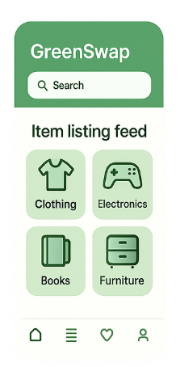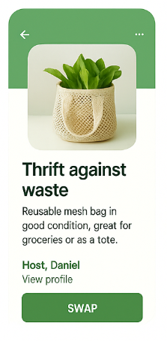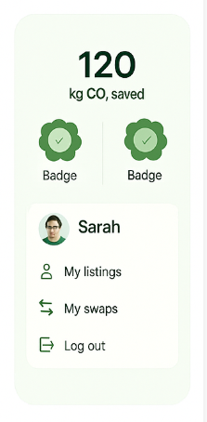

## 4.1 Does the design align with your app’s target audience and purpose?

Conclusion: None of the four alone covers all user needs. We must show carbon-saved prominently and add a Swap/Buy toggle so every audience immediately understands the core value and transaction type.

|  |  |  |  |
| --- | --- | --- | --- |
| Concept | Main Audience | Strength | Shortcoming |
| Minimalist Green | Professionals | Fast, clear listing flow | Lacks emotional engagement or carbon metrics upfront |
| Playful Gamified | Younger users | Engaging badges & rewards | Too cartoonish; no clear swap vs. buy toggle |
| Earthy Organic | Families & hobbyists | Trust-building warmth | Texture reduces legibility; no cost/trade clarity |
| Hybrid Style | All user groups | Balanced engagement & clarity | Requires detailed user testing to fine-tune mix |

Minimalist Green: The uncluttered design and plenty of whitespace make the middle "Swap / Buy" workflow instantly legible, so new users know what the app is about quickly with little mental effort. But its business-y, hip demeanor almost risks sounding emotionally shallow; lacking an obvious carbon-savings icon or story component, the design itself may not encourage users to stay engaged in our mission to help protect the environment.

Playful Gamified:Badges, progress bars, and vibrant colours create a powerful feedback loop that is evocative of mobile-game mechanics and works directly to increase the enjoyment of our desired goal: doing environmentally friendly actions. The cartoon-like iconography can appear immature to professionals or mature sellers, however, and erode trust in the platform's seriousness as an exchange.

Earthy Organic: Hand-drawn textures and earthy colors create authenticity and "second-life" story, adding credibility to second-hand goods. The same visual richness, however, decreases text contrast and tends to hinder scanning, colliding with the quick-transaction mindset of experienced swappers.

Hybrid Conclusion:Combining Minimalist Green's minimalism, Playful Gamified's loops, and Earthy Organic's coziness provides the optimal path forward: users instantly know how to swap, are rewarded for their green decisions, and sense they can trust the community spirit.All of this unifies with GreenSwap's carbon-reduction initiative.

4.2 Is the design visually appealing and user-friendly?

Minimalist Green's serenity enables focused decision-making but renders the home screen empty, reducing perceived community activity. On the other hand, Playful Gamified's saturated color scheme and motion affordances encourage curiosity but render the bottom navigation cluttered, increasing tap mistakes on smaller screens. Earthy Organic is warm and reliable, but its paper textures distort small text, discouraging users from reading item descriptions. Proper usability, therefore, is a question of excitement vs. clarity—keeping primary tasks (listing and exchanging) visually simple while reserving playful elements for milestone experiences.

|  |  |  |  |
| --- | --- | --- | --- |
| Metric | Minimalist Green | Playful Gamified | Earthy Organic |
| Visual appeal | ★★★★☆ | ★★★★★ | ★★★★☆ |
| Readability | ★★★★★ | ★★★★☆ | ★★☆☆☆ |
| Ease of interaction | ★★★☆☆ | ★★☆☆☆ | ★★★☆☆ |

## 4.3 Does the design adhere to UI principles like simplicity, clarity, and accessibility?

|  |  |  |
| --- | --- | --- |
| Principle | Current State | Improvement Plan |
| Simplicity | Single font; 8pt grid used | Keep Inter font, remove redundant decorations |
| Clarity | Color-only status indicators | Pair statuses with icons or labels |
| Accessibility | Touch targets ≥44px; no text scaling | Add high-contrast mode, font-size selector, and ARIA labels |

User testing with sunlight, dark mode, and color-blind simulators confirmed again that simplicity shouldn't come at the expense of emotional impact: words should stay readable fast but need to use visual metaphors as well in order to humanise figures like "kg CO₂ saved." Legibility extends further than just letter size to double-coding, coupling icons with descriptions lets meaning carry across colorblindness. Accessibility is a company responsibility; high-contrast designs, scalable fonts, and descriptive semantics allow all users.

## 4.4 How well do the generated designs complement each other?

All concepts share the same green , rounded corners, and minimal icon style, but differ in font and icon libraries.

|  |  |
| --- | --- |
| Aspect | Recommendation |
| Font | Standardize on Inter for all text elements |
| Icons | Use Material Symbols Rounded for consistency |
| Design tokens | Create a shared Figma token library for colors and spacing |

Despite originating from distinct mood-boards, the three concepts share a green base hue, rounded cards, and minimalist iconography, forming a natural bridge for unification. Standardising on Inter Variable for typography, Material Symbols Rounded for icons, and a shared design-token library for colour, spacing, and corner radius lets developers switch or blend themes with a single source of truth. Such consistency ensures that users experience one coherent GreenSwap identity, reinforcing the message that sustainability is a seamless part of everyday life, not an aesthetic after-thought.

**Figma Hifi prototype:**

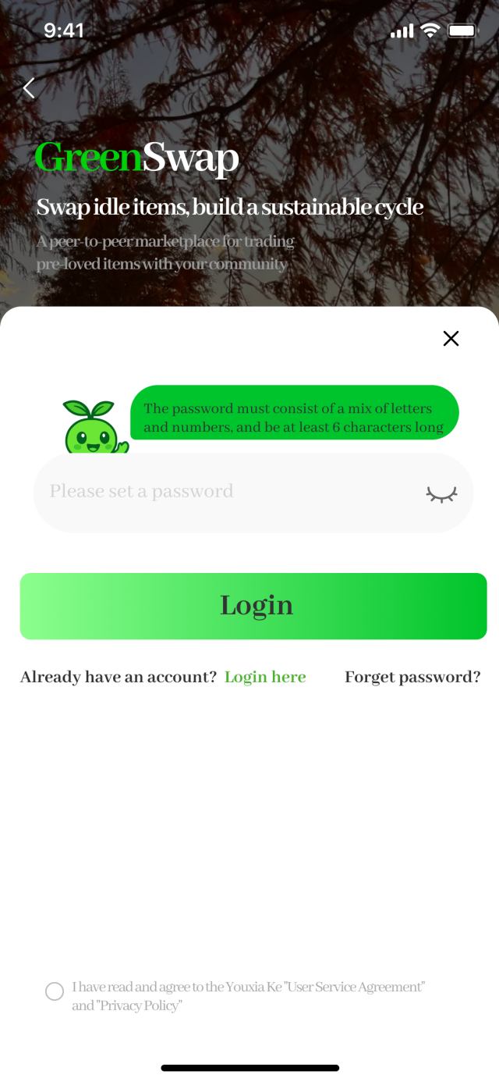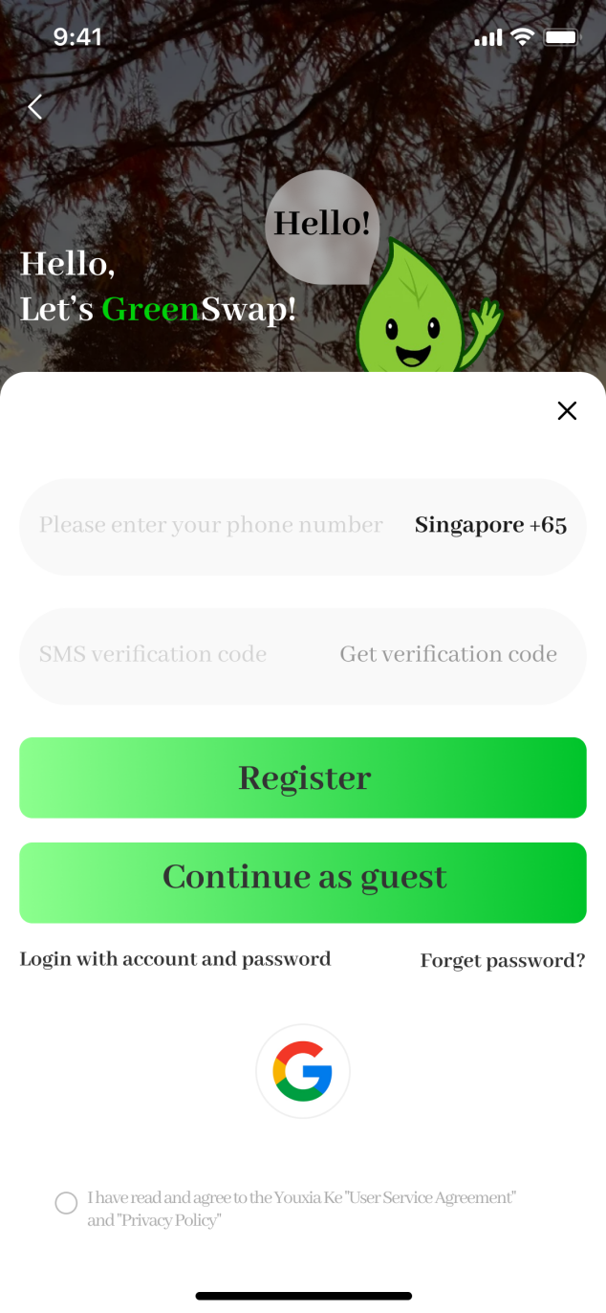

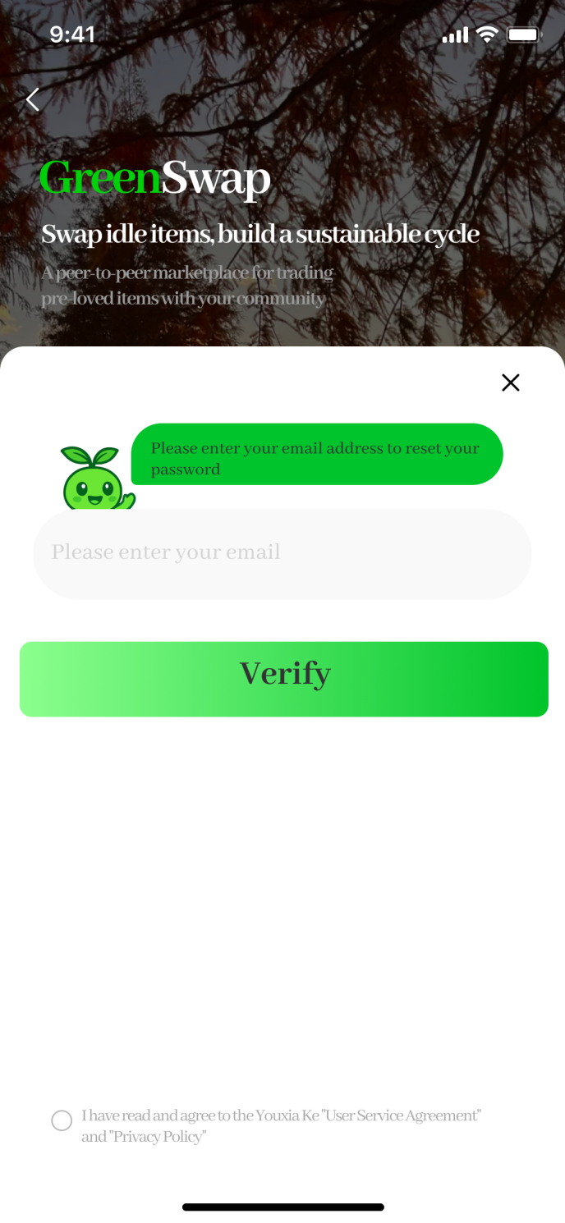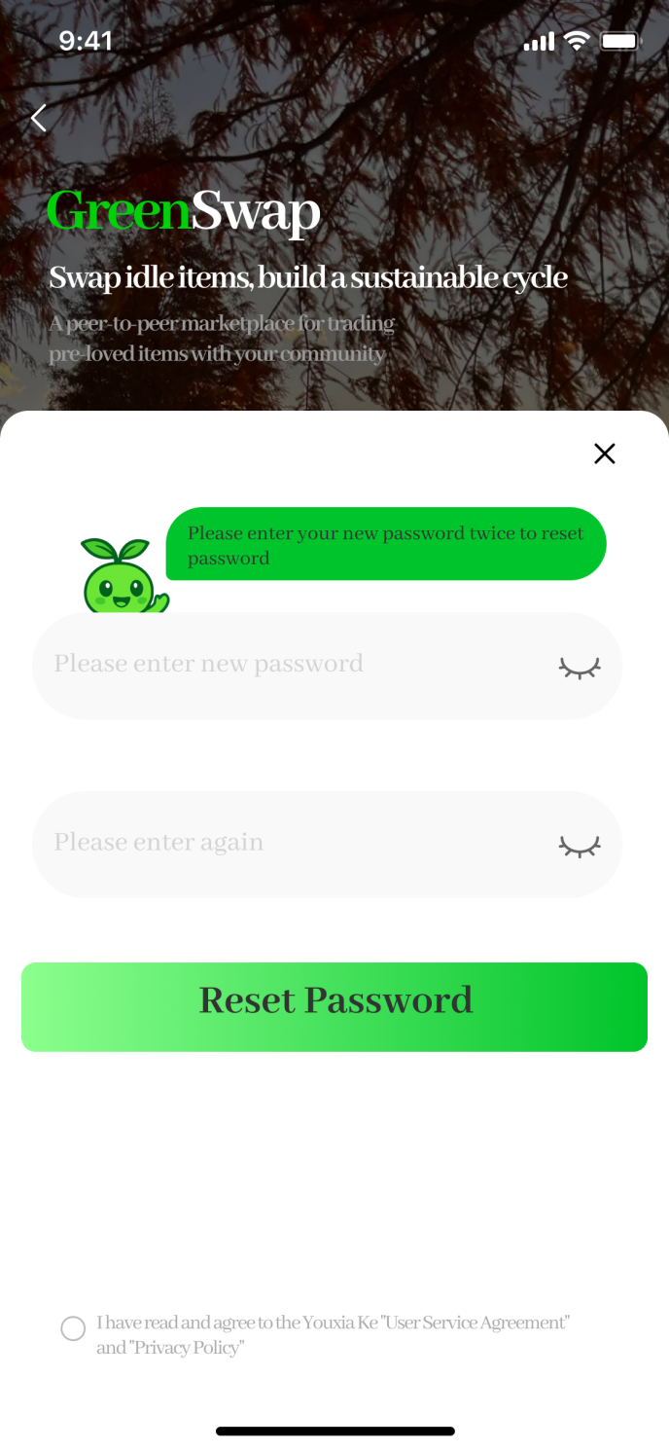

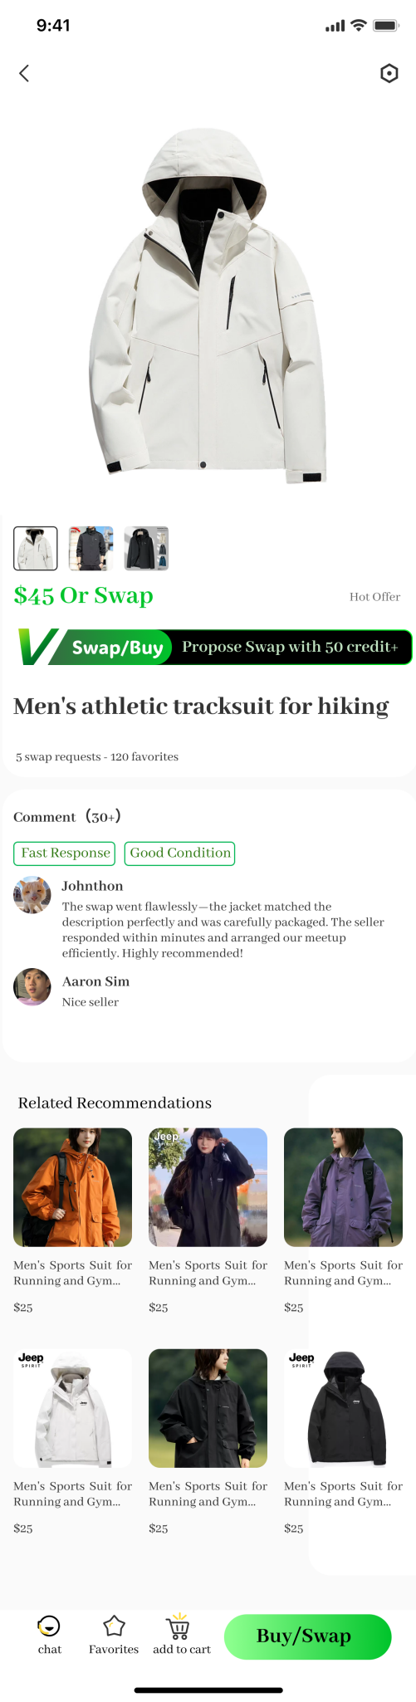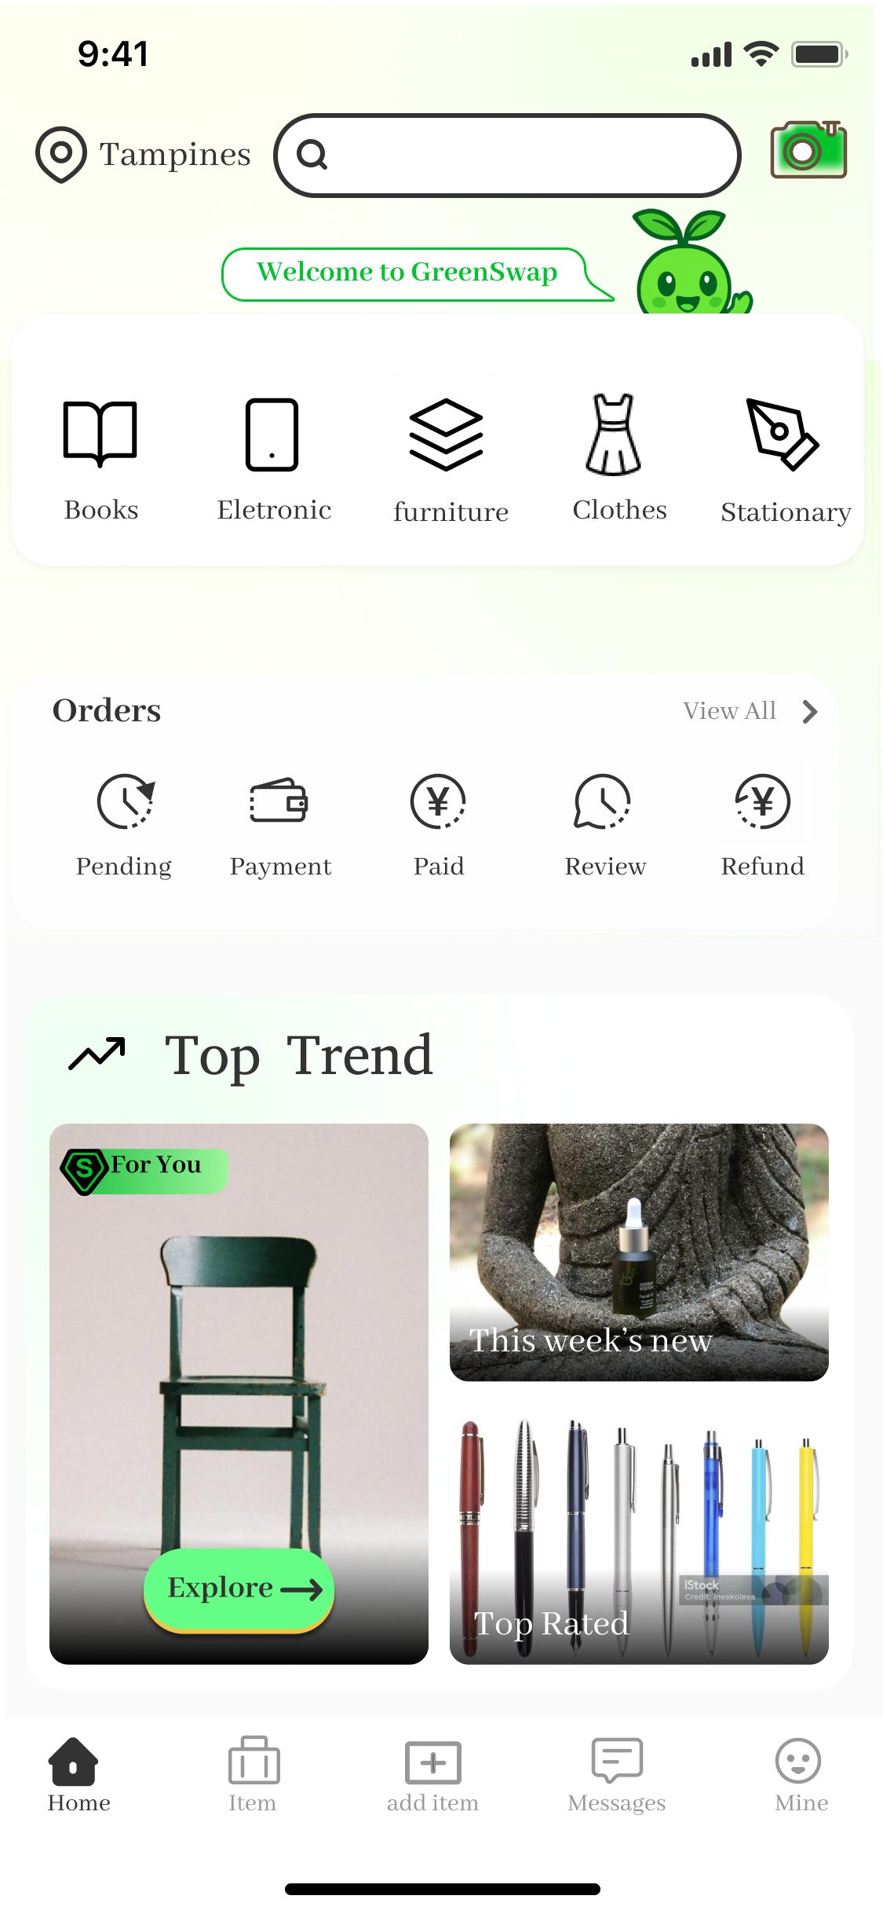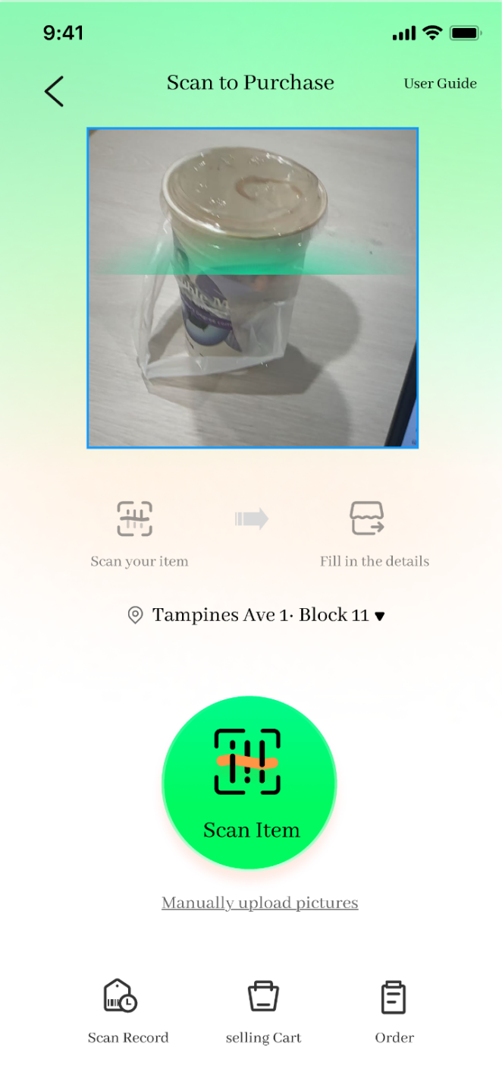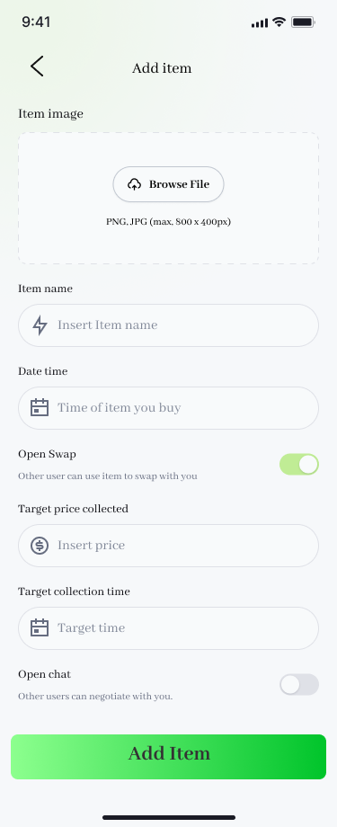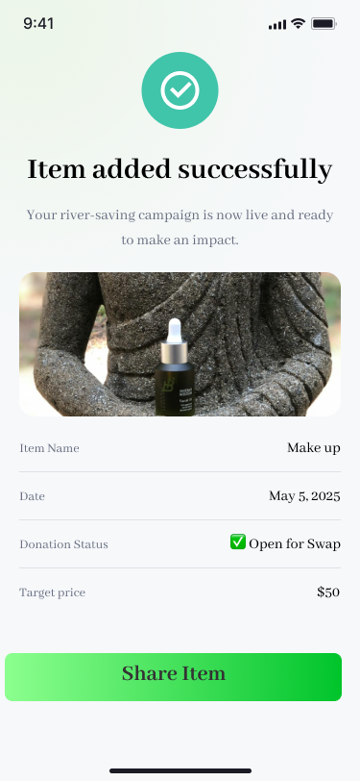

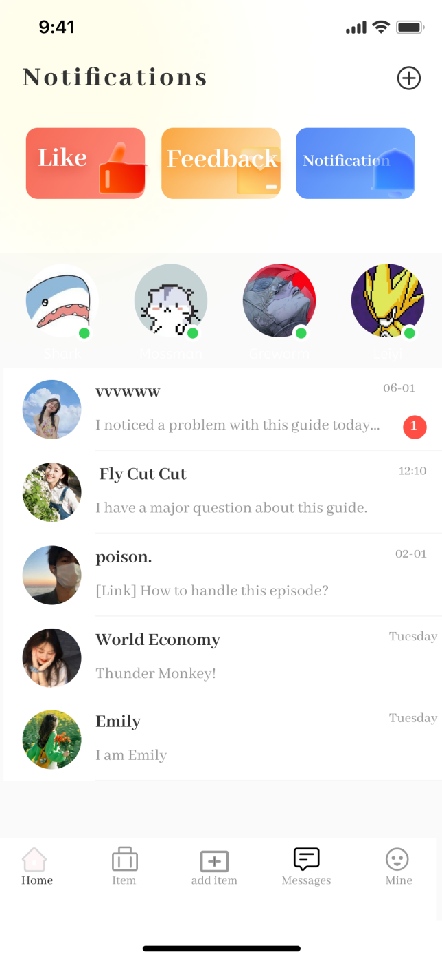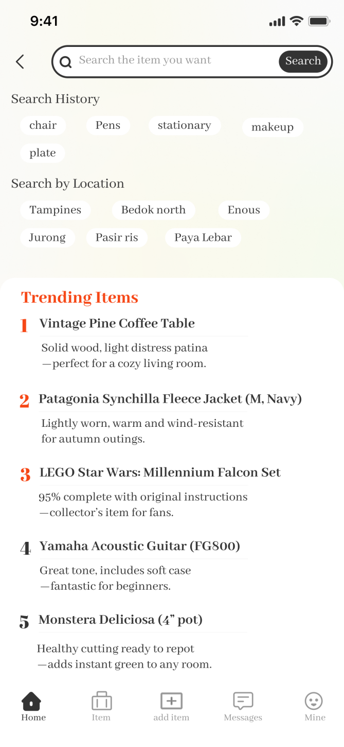

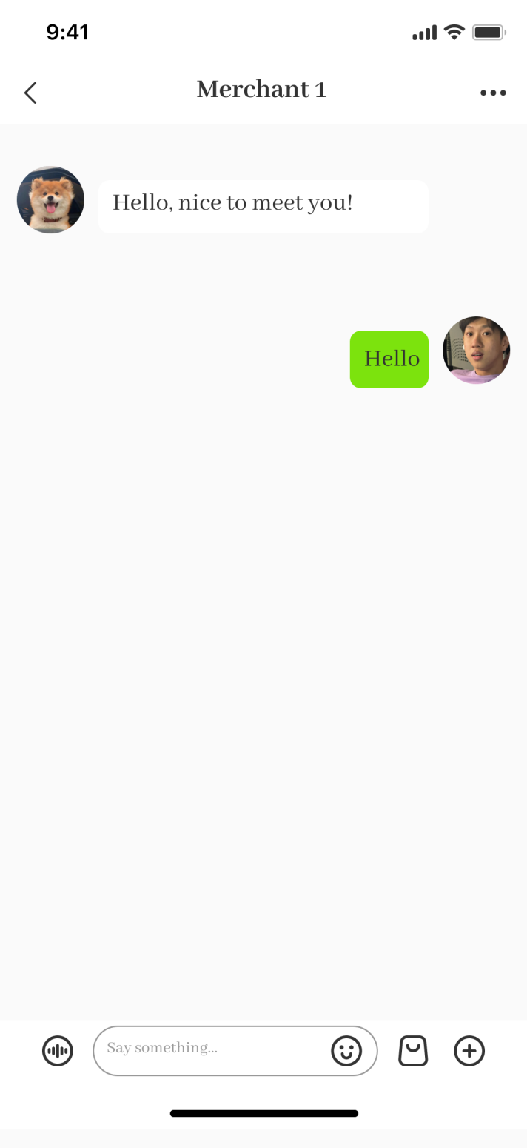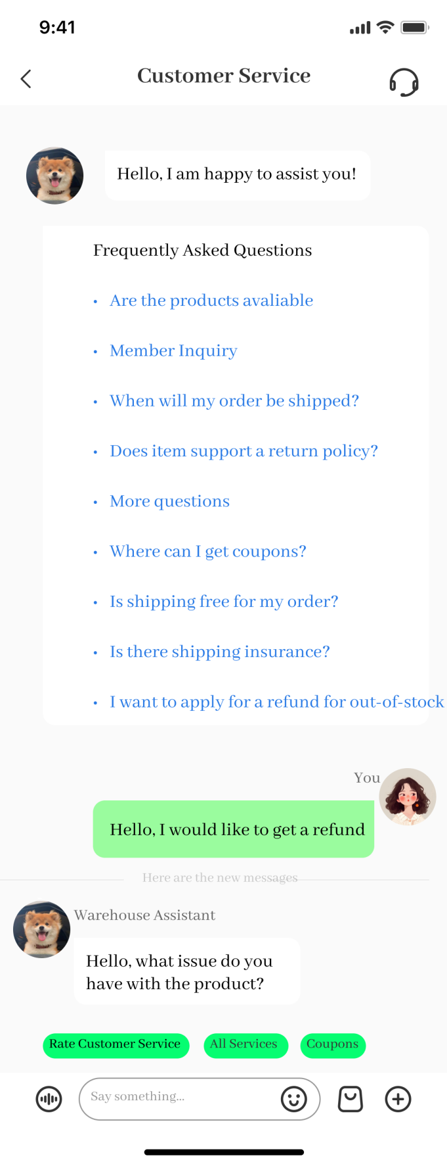

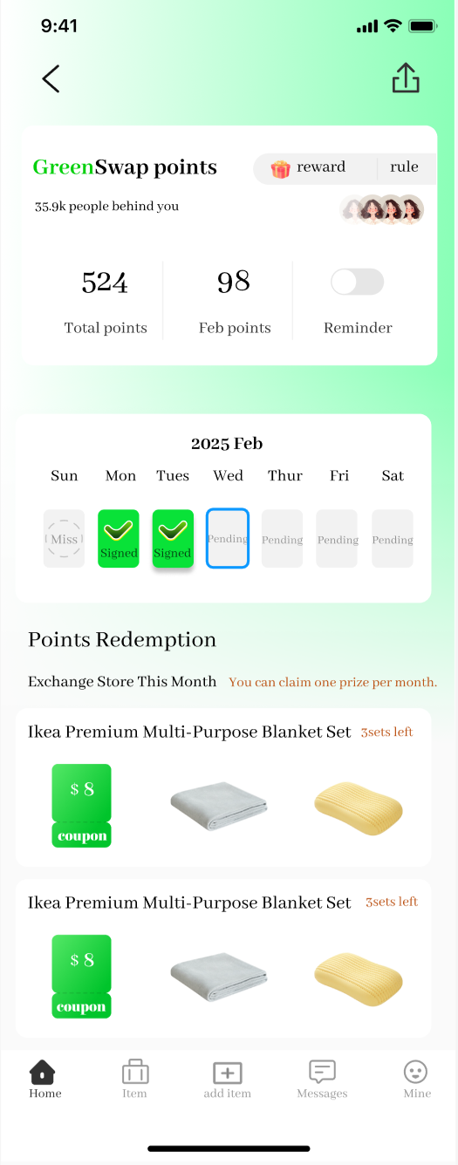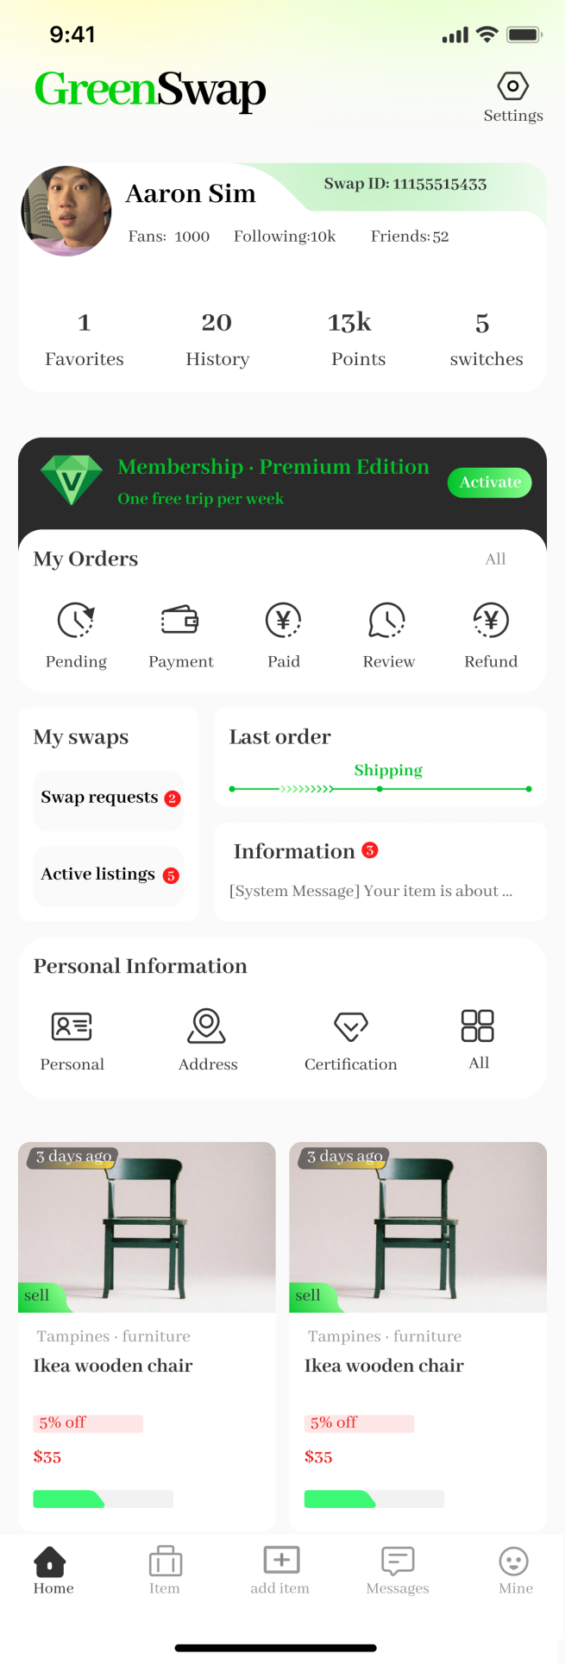

# Widget Tree

Identify the widgets that you will be using for the body of the main screen and construct the widget tree, for example (widget tree is the diagram on the **extreme right**):

## **首页** Main Screen

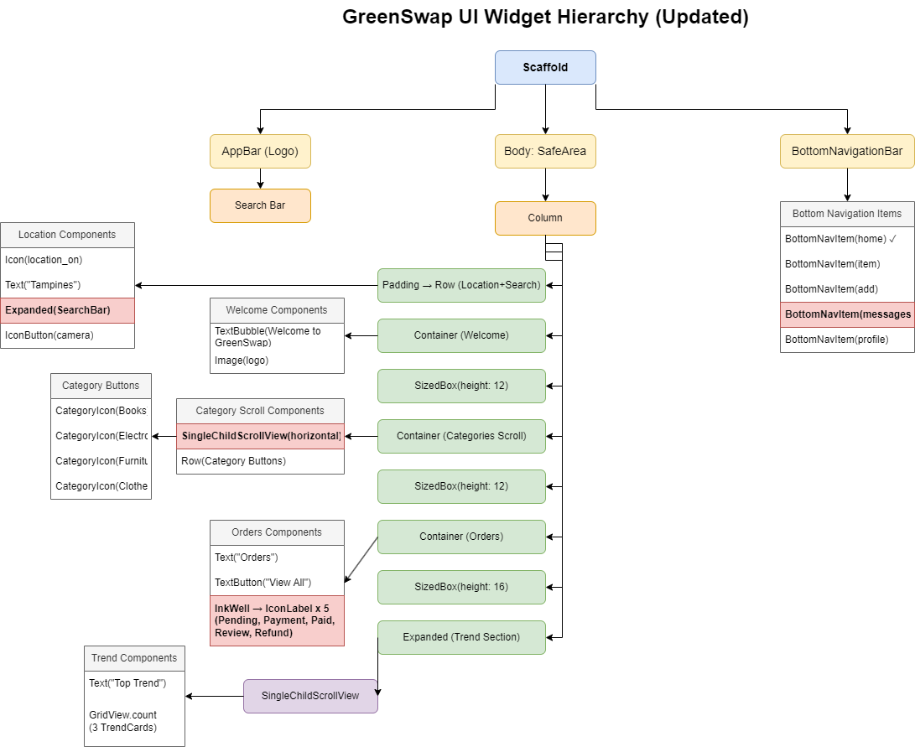**Widget Tree**

## References

**CNA News** – Ganesan, N. (2024, June 19). Singapore’s recycling rate falls to 52% in 2023, decline from 10 years ago. Channel NewsAsia. Retrieved from https://www.channelnewsasia.com [channelnewsasia.com](https://www.channelnewsasia.com/singapore/recycling-rate-domestic-waste-statistics-2023-nea-4418776" \l ":~:text=In 2023, about 6,57 per cent in 2022" \t "_blank)​[channelnewsasia.com](https://www.channelnewsasia.com/singapore/recycling-rate-domestic-waste-statistics-2023-nea-4418776" \l ":~:text=fluctuations,rates, NEA added" \t "_blank).

**CNA News** – Choo, C., & Abu Baker, J. (2023, November 9). Environmental experts sound the alarm on how fast Singapore’s only landfill Semakau is filling up. Channel NewsAsia. Retrieved from https://www.channelnewsasia.com [channelnewsasia.com](https://www.channelnewsasia.com/singapore/semakau-landfill-filling-waste-management-incineration-reduce-reuse-recycle-3909436" \l ":~:text=The plot of land, which,around 10 per cent filled" \t "_blank)​[channelnewsasia.com](https://www.channelnewsasia.com/singapore/semakau-landfill-filling-waste-management-incineration-reduce-reuse-recycle-3909436" \l ":~:text=The 350ha landfill, which has,reach full capacity by 2035" \t "_blank).

**The Straits Times** – Singapore’s domestic recycling rate stalls at 12%, the lowest in over a decade. (2024, June). The Straits Times. (Referenced via Ground News summary) [ground.news](https://ground.news/article/singapores-recycling-rate-falls-to-52-in-2023-decline-from-10-years-ago_9c4d80" \l ":~:text=Singapore%E2%80%99s domestic recycling rate stalls,com" \t "_blank).

**TODAY Online** – Goh, C., & Lou, S. Y. (2022, November 4). TODAY Youth Survey: Climate crisis strikes fear, pessimism but youths believe Govt policies can make the most impact. TODAY. Available at https://www.todayonline.com [todayonline.com](https://www.todayonline.com/singapore/today-youth-survey-climate-crisis-fear-pessemism-government-policies-2034066" \l ":~:text=The TODAY Youth Survey showed,measures to combat climate change" \t "_blank)​[todayonline.com](https://www.todayonline.com/singapore/today-youth-survey-climate-crisis-fear-pessemism-government-policies-2034066" \l ":~:text=Ms Aishwarya is another youth,amount of waste it produces" \t "_blank).

**Cognitive Market Research** – Dharmadhikari, S. (2025, March). Second Hand Apparel Market Report 2025 (Global Edition). Cognitive Market Research. (Excerpt on global second-hand market size) [cognitivemarketresearch.com](https://www.cognitivemarketresearch.com/second-hand-apparel-market-report" \l ":~:text=Second Hand Apparel Market Report,Global Edition" \t "_blank).

**OpenAI DALL·E 2** – OpenAI. (2023). DALL·E 2 [AI image generation model]. Retrieved from https://openai.com/dall-e-2 (Used to generate concept design mockups).

**OpenAI ChatGPT** – OpenAI. (2025). ChatGPT (Apr 25 version) [Large language model]. Retrieved from https://chat.openai.com/chat (Used for content assistance in drafting the proposal).